Accessible Educational Materials (AEM)

Power BI Report Implementation Guide

**March 2024**

# Introduction

This implementation guide is the reference document for the Accessible Educational Materials (AEM) Report, a Power BI report. It can be connected to a state’s instance of the CEDS Data Warehouse, enabling State Education Agencies (SEAs) and Local Education Agencies (LEAs) to utilize data on accessible educational materials (AEM), for the purpose of improving the provision and use of AEM for students with disabilities who need them, by identifying data gaps in data collection and providing outputs to enhance data driven decisions.

# Background

This report leverages five previously developed CEDS connections, which aim to standardize data collection in areas where SEAs (State Education Agencies), LEAs (Local Education Agencies), and schools are not currently required to collect data. Despite the absence of this data, the creation of the Power BI report and its underlying CEDS connections seeks to encourage the gathering of information. This initiative is designed to support the analysis of policy questions related to the accessibility of educational materials and technologies, as well as to identify and address disparities and barriers in access to these resources.

Below are the links to the CEDS connections leveraged in this report:

* [Does the Student with a Disability Require Accessible Format(s)?](https://ceds.ed.gov/connectReport.aspx?uid=30878)
* [Number of Students with Disabilities Issued Accessible Formats](https://ceds.ed.gov/connectReport.aspx?uid=30853)
* [Process by Which Accessible Formats are Provided to Students with Disabilities](https://ceds.ed.gov/connectReport.aspx?uid=30873)
* [Provision of Accessible Formats in a Timely Manner](https://ceds.ed.gov/connectReport.aspx?uid=30879)
* [What Type of Accessible Format(s) Does a Student with a Disability Require?](https://ceds.ed.gov/connectReport.aspx?uid=30867)

# Prerequisites

* This report requires states to be users of CEDS Data Warehouse.
* The latest version of Power BI Desktop
* Access to the CEDS Data Warehouse
* VPN Access if required

# Preparing CEDS Data Warehouse

The Accessible Educational Materials report uses stored views of data in the Reporting Tables. These views are not standard but can be added to your instance of CEDS’s semantic layer easily. This process does not require any server backups.

The views contain fact and dimension table IDs that are joined with other fact and dimension tables within the data warehouse to return other data elements used within the BI report.

## The Required View

Listed below is a custom table created specifically for this report:

* vwAccessibleEducationMaterialAssignments
  + Description: All students that are enrolled in a school for the report year with either an IEP/504, are in grades PK through 12 and are between the ages 3-21.
  + Primary Field:
    - Fact.K12StudentId

## Adding the Views

To add the required views, download the ‘vwAccessibleEducationMaterialAssignments.txt’ file from the “SQL Views” folder in GitHub.

Open each view in your SQL Management Studio (or similar) open and execute the view into your copy of the data warehouse. This will add the required views.

If you change the name, field names, or the values returned, you will need to update the BI tool to reflect the changes.

# Connecting the report to the source

The .pbix file with a copy of the report is available in the CEDS Collaborative Exchange’s GitHub folder: https://github.com/CEDS-Collaborative-Exchange/AEM-Center-Reports

The downloaded report contains cached test data and is not intended to represent any actual state data. To use the report with your state’s data, **you will need to connect your instance of the report using your CEDS Data Warehouse**.

Remember to connect to the VPN if required by your network administrators.

After downloading the .pbix file, open it in your instance of Power BI Desktop. As a reminder, the data in the report after the initial download will be cached test data.

To use your data in the report, connect it to the CEDS data warehouse. Start this process by clicking Transform Data in the home ribbon. In the dropdown menu, select Transform Data. This will open Power Query.

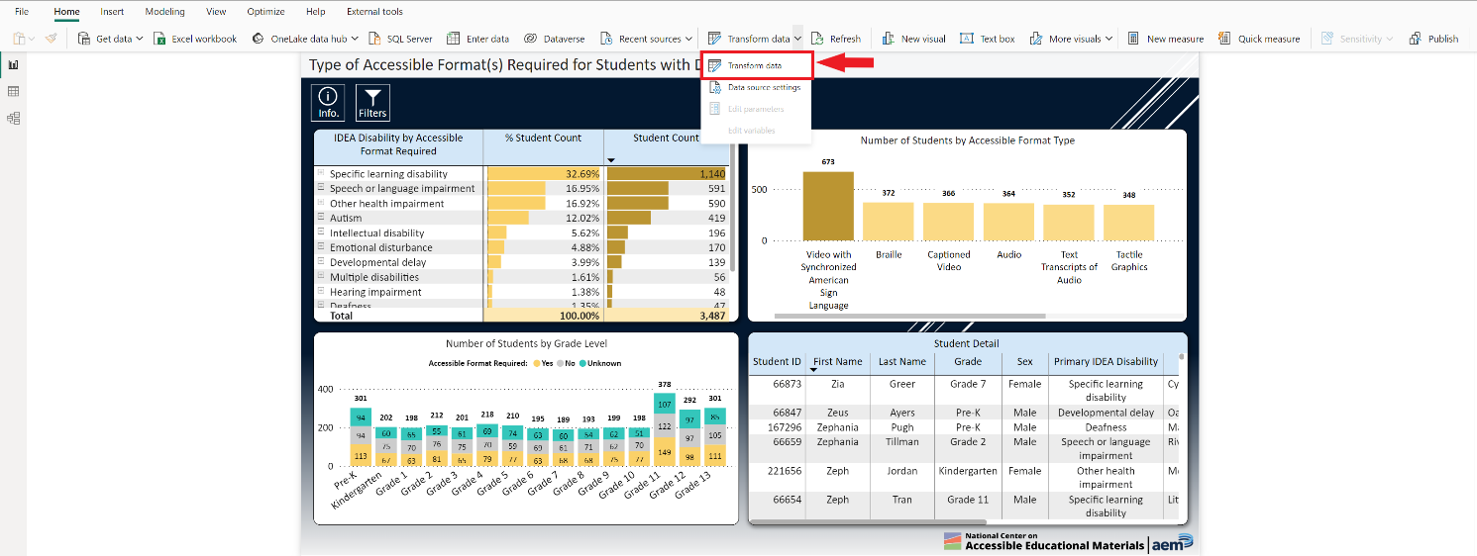

In Power Query, the queries contain a list of tables and report measures essential to the report. Each table needs to be pointed to your CEDS Data Warehouse to ensure that the correct source data is used for the report. This includes each of the queries in the following folders:

* Fact Tables
* Dimension Tables

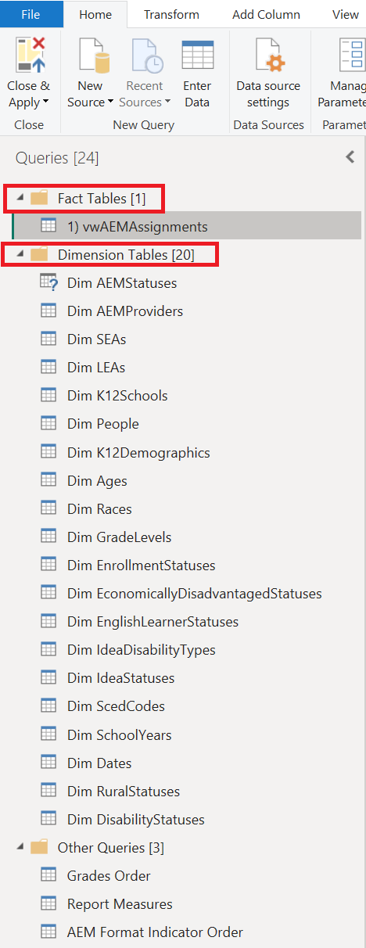

Click on each table, and then select the advanced editor.

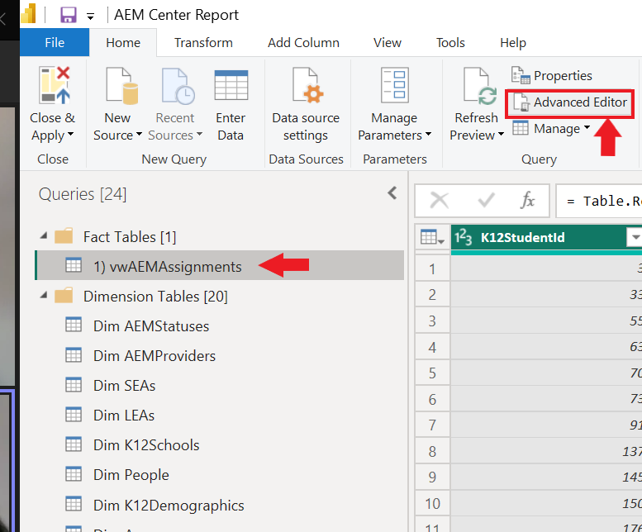

In the advanced editor update the IP Address in one place, and the Database name in three places. This will need to happen in each of the following tables:

* 1) vwAEMAssignments
* Dim AEMStatuses
* Dim AEMProviders
* Dim SEAs
* Dim LEAs
* Dim K12Schools
* Dim People
* Dim K12Demographics
* Dim Ages
* Dim Races
* Dim GradeLevels
* Dim EnrollmentStatuses
* Dim EconomicallyDisadvantagedStatuses
* Dim EnglishLearner Statuses
* Dim IdeaDisabilityTypes
* Dim Idea Statuses
* Dim ScedCodes
* Dim SchoolYears
* Dim Dates
* Dim RuralStatuses
* Dim DisabilityStatuses

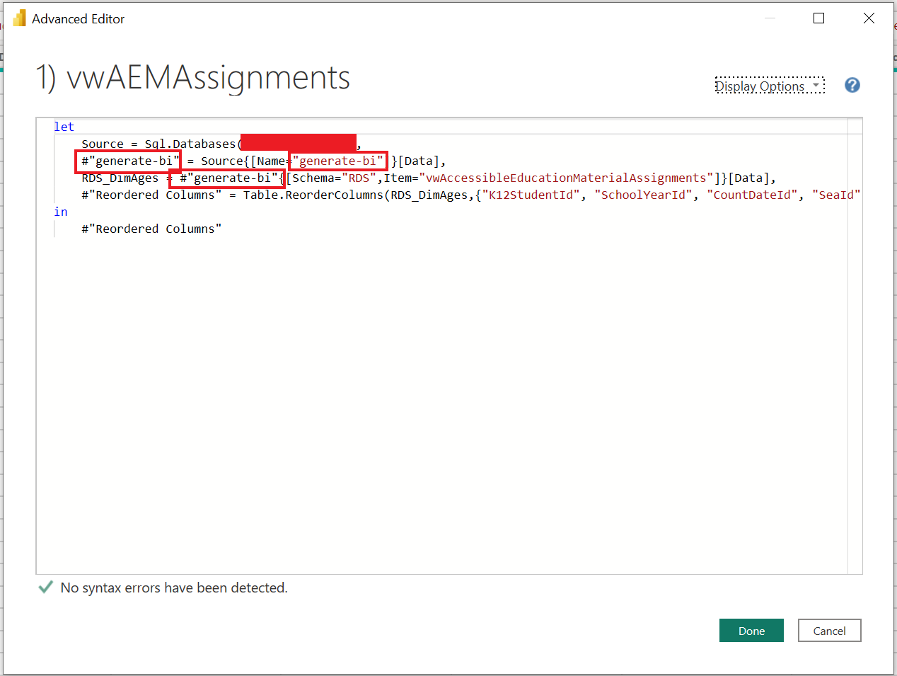

After each table is updated with the name and IP address of your CEDS Data Warehouse, click close and apply. Your dataset will now refresh and cache within your report. This may take a few minutes, depending on the size of your dataset.

After the dataset is updated, close Power Query. After connecting the dataset, the front end of the report can be reviewed and used.

# Distribution

This report contains Student ID numbers and other PII, so ensuring that it is shared only with authorized individuals is important. Refer to your SEA’s policies and procedures before sharing this report. While the .pbix can be sent to individuals with Power BI Desktop, it is recommended that this report is distributed with internal state staff through an Online Power BI Workspace. Doing this ensures that access can be limited to appropriate individuals, that the report cannot be edited, and provides multiple sharing options, such as embedding into a Teams Channel.

To share through an online workspace, sign into office.com, and select Power BI on the menu icon. In Power BI, create a new workspace in Power BI by adding the required information.

Once the workspace is created, upload the .pbix file to the workspace.

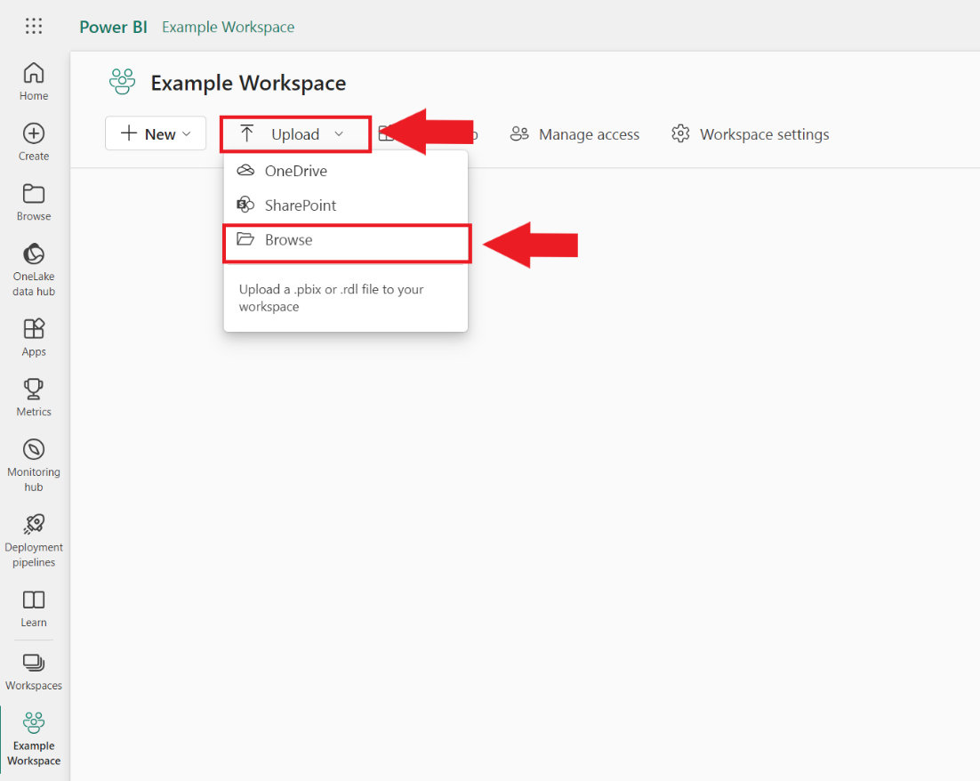

After the report is uploaded in the workspace, the dashboard will be available to use and share by clicking on the .pbix file.

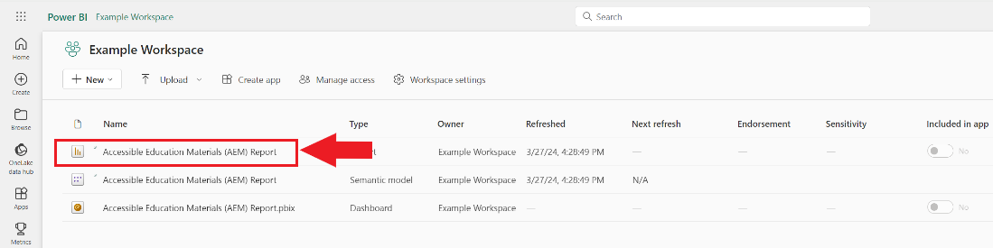

Once you have navigated to the report, manage permissions to access the dashboard with appropriate individuals in your organization, by clicking share.

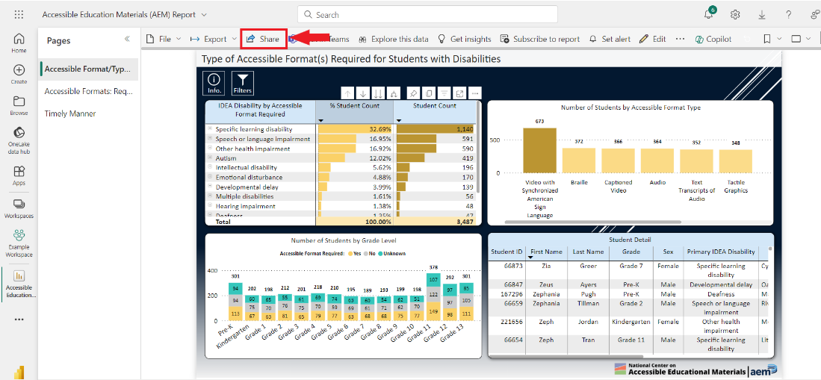

Type in the name of the person you want to share with. Then click the method you would like to send through.

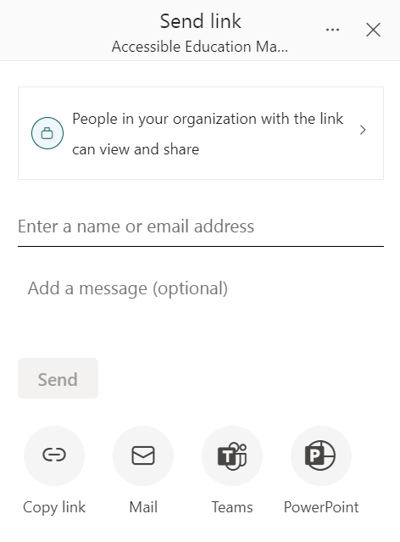

# Refreshing Data

Administrators of the report can refresh the data in different ways:

* If using the report as a desktop .pbix file, then click the refresh button to view updated data.
  + If this report is being used in the workspace, after refreshing data, then click publish to allow authorized users to view the data.
* To refresh from workspace, go to the semantic model and click the refresh button.

